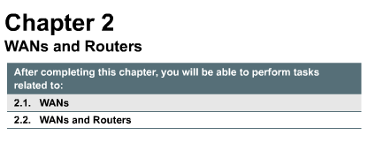
Chapter 2, a short chapter, which can be covered fairly quickly, serves to contextualize the upcoming router IOS focus within the WAN environment so dependent on routing. In other words, this chapter attempts to answer the question, "why spend so much time learning router configuration?"

Now that you have a firm understanding of the OSI reference model, LANs, and IP addressing, you are ready to learn about and use the Cisco Internetwork Operating System (IOS). However, before using the IOS, it is important to have firm grasp of WAN and router basics. Therefore, in this chapter, you will learn about WAN devices, technologies, and standards. In addition, you will learn about the function of a router in a WAN. Lastly, you will perform lab activities related to a router lab setup and configuration.
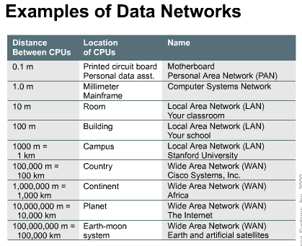
A WAN (wide area network) operates at the physical layer and the data link layer of the OSI reference model. It interconnects LANs (local area networks) that are usually separated by large geographic areas. WANs provide for the exchange of data packets/frames between routers/bridges and the LANs they support.
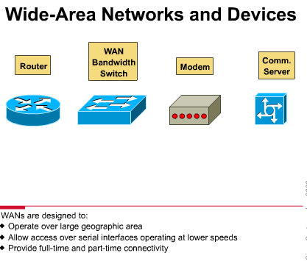
The major characteristics of WANs are:
- They operate beyond the local LANs geographic scope. They use the services of carriers such as the Regional Bell Operating Companies (RBOCs) and Sprint and MCI.
- They use serial connections of various types to access bandwidth over wide-area geographies.
- By definition, WANs connect devices that are separated by wide geographical areas. Such devices include:
- routers -- offer many services, including internetworking and WAN interface ports
- switches -- connect to WAN bandwidth for voice, data, and video communication
- modems -- interface voice-grade services; channel service units/digital service units (CSU/DSUs) that interface T1/E1 services; and Terminal Adapters/Network Termination 1 (TA/NT1s) that interface Integrated Services Digital Network (ISDN) services
- communication servers -- concentrate dial-in and dial-out user communication
Some WAN technologies, especially layer 2 WAN frame standards, are introduced. These topics will be covered in great detail in semester 4, but they are relevant to giving a context for router configuration. Best Practices for teaching this TI include Mini-Lecture and Online Study with Study Guides. This TI relates to CCNA Certification Exam Objective #8.
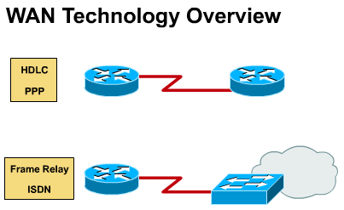
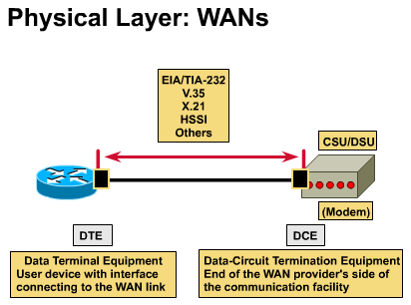
WAN physical layer protocols describe how to provide electrical, mechanical, operational, and functional connections for WAN services. These services are most often obtained from WAN service providers such as RBOCs, alternate carriers, post-telephone, and telegraph (PTT) agencies.
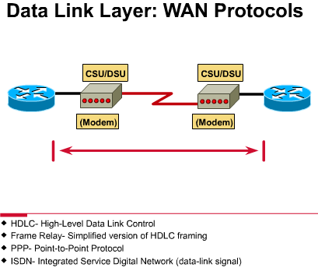
WAN data link protocols describe how frames are carried between systems on a single data link. They include protocols designed to operate over dedicated point-to-point, multipoint, and multi-access switched services such as Frame Relay. WAN standards are defined and managed by a number of recognized authorities, including the following agencies:
- International Telecommunication Union-Telecommunication Standardization Sector (ITU-T), formerly the Consultative Committee for International Telegraph and Telephone (CCITT)
- International Organization for Standardization (ISO)
- Internet Engineering Task Force (IETF)
- Electronic Industries Association (EIA)
WAN standards typically describe both physical layer and data link layer requirements. The WAN physical layer describes the interface between the data terminal equipment (DTE) and the data circuit-terminating equipment (DCE). Typically, the DCE is the service provider and the DTE is the attached device. In this model, the services offered to the DTE are made available through a modem or a CSU/DSU.
Several physical layer standards specify this interface:
- EIA/TIA-232
- EIA/TIA-449
- V.24
- V.35
- X.21
- G.703
- EIA-530
The common data link encapsulations associated with synchronous serial lines are listed in Figure :
- High-Level Data Link Control (HDLC) -- an IEEE standard; may not be compatible with different vendors because of the way each vendor has chosen to implement it. HDLC supports both point-to-point and multipoint configurations with minimal overhead
- Frame Relay -- uses high-quality digital facilities; uses simplified framing with no error correction mechanisms, which means it can send Layer 2 information much more rapidly than other WAN protocols
- Point-to-Point Protocol (PPP) -- described by RFC 1661; two standards developed by the IETF; contains a protocol field to identify the network layer protocol
- Simple Data Link Control Protocol (SDLC) -- an IBM-designed WAN data link protocol for System Network Architecture (SNA) environments; largely being replaced by the more versatile HDLC
- Serial Line Interface Protocol (SLIP) -- an extremely popular WAN data link protocol for carrying IP packets; being replaced in many applications by the more versatile PPP
- Link Access Procedure Balanced (LAPB) -- a data link protocol used by X.25; has extensive error checking capabilities
- Link Access Procedure D-channel (LAPD) -- the WAN data link protocol used for signaling and call setup on an ISDN D-channel. Data transmissions take place on the ISDN B channels
- Link Access Procedure Frame (LAPF) -- for Frame-Mode Bearer Services; a WAN data link protocol, similar to LAPD, used with frame relay technologies
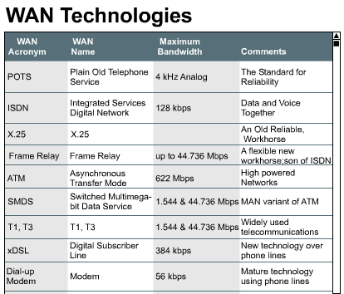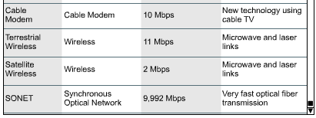
Following is a brief description of the most common WAN technologies. They have been grouped into circuit-switched, cell-switched, dedicated digital, and analog services. For more information click on the Web links that are included.
Circuit-Switched Services
- POTS (Plain Old Telephone Service) -- not a computer data service, but included for two reasons: (1) many of its technologies are part of the growing data infrastructure, (2) it is a model of an incredibly reliable, easy-to-use, wide-area communications network; typical medium is twisted-pair copper wire
- Narrowband ISDN (Integrated Services Digital Network) -- a versatile, widespread, historically important technology; was the first all-digital dial-up service; usage varies greatly from country to country; cost is moderate; maximum bandwidth is 128 kbps for the lower cost BRI (Basic Rate Interface) and about 3 Mbps for the PRI (Primary Rate Interface); usage is fairly widespread, though it varies considerably from country to country; typical medium is twisted-pair copper wire
Packet-Switched Services
- X.25 -- an older technology, but still widely used; has extensive error-checking capabilities from the days when WAN links were more prone to errors, which make it reliable but limits its bandwidth; bandwidth may be as high as 2 Mbps; usage is fairly extensive; cost is moderate; typical medium is twisted-pair copper wire
- Frame Relay -- a packet-switched version of Narrowband ISDN; has become an extremely popular WAN technology in its own right; more efficient than X.25, but with similar services; maximum bandwidth is 44.736 Mbps; 56kbps and 384kbps are extremely popular in the U.S.; usage is widespread; cost is moderate to low; Typical media include twisted-pair copper wire and optical fiber
Cell-Switched Services
- ATM (Asynchronous Transfer Mode) -- closely related to broadband ISDN; becoming an increasingly important WAN (and even LAN) technology; uses small, fixed length (53 byte) frames to carry data; maximum bandwidth is currently 622 Mbps, though higher speeds are being developed; typical media are twisted-pair copper wire and optical fiber; usage is widespread and increasing; cost is high
- SMDS (Switched Multimegabit Data Service) -- closely related to ATM, and typically used in MANs; maximum bandwidth is 44.736 Mbps; typical media are twisted-pair copper wire and optical fiber; usage not very widespread; cost is relatively high
Dedicated Digital Services
- T1, T3, E1, E3 -- the T series of services in the U.S. and the E series of services in Europe are extremely important WAN technologies; they use time division multiplexing to "slice up" and assign time slots for data transmission; bandwidth is:
- T1 -- 1.544 Mbps
- T3 -- 44.736 Mbps
- E1 -- 2.048 Mbps
- E3 -- 34.368 Mbps
- other bandwidths are available
The media used are typical twisted-pair copper wire and optical fiber. Usage is extremely widespread; cost is moderate.
- xDSL (DSL for Digital Subscriber Line and x for a family of technologies) -- a new and developing WAN technology intended for home use; has a bandwidth which decreases with increasing distance from the phone companies equipment; top speeds of 51.84 Mbps are possible near a phone company office, more common are much lower bandwidths (from 100s of kbps to several Mbps); usage is small but increasing rapidly; cost is moderate and decreasing; x indicates the entire family of DSL technologies, including:
- HDSL -- high-bit-rate DSL
- SDSL -- single-line DSL
- ADSL -- asymmetric DSL
- VDSL -- very-high-bit-rate DSL
- RADSL -- rate adaptive DSL
- SONET (Synchronous Optical Network) -- a family of very high-speed physical layer technologies; designed for optical fiber, but can also run on copper cables; has a series of data rates available with special designations; implemented at different OC (optical carrier) levels ranging from 51.84 Mbps (OC-1) to 9,952 Mbps (OC-192); can achieve these amazing data rates by using wavelength division multiplexing (WDM), in which lasers are tuned to slightly different colors (wavelengths) in order to send huge amounts of data optically; usage is widespread among Internet backbone entities; cost is expensive (not a technology that connects to your house)
Other WAN Services
- dial-up modems (switched analog) -- limited in speed, but quite versatile; works with existing phone network; maximum bandwidth approx. 56 kbps; cost is low; usage is still very widespread; typical medium is the twisted-pair phone line
- cable modems (shared analog) -- put data signals on the same cable as television signals; increasing in popularity in regions that have large amounts of existing cable TV coaxial cable (90% of homes in U.S.); maximum bandwidth can be 10 Mbps, though this degrades as more users attach to a given network segment (behaving like an unswitched LAN); cost is relatively low; usage is small but increasing; the medium is coaxial cable.
- wireless -- no medium is required since the signals are electromagnetic waves; there are a variety of wireless WAN links, two of which are:
- terrestrial -- bandwidths typically in the 11 Mbps range (e.g. microwave); cost is relatively low; line-of-sight is usually required; usage is moderate
- satellite -- can serve mobile users (e.g. cellular telephone network) and remote users (too far from any wires or cables); usage is widespread; cost is high
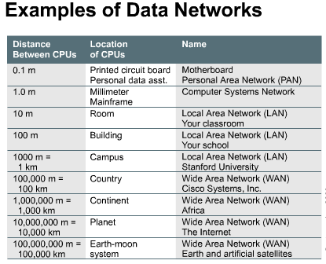
This TI serves two purposes. First, it introduces the router as a special purpose computer and as a small-scale network-in-a-box. Second, a sample router configuration - which the students are not expected to really understand at any depth - is shown in graphic #2. The purpose is to contextualize the upcoming router configuration tasks. Point out that just as a computer cannot work with out an operating system and applications software, a router cannot work without an operating system and configurations. Best Practices for teaching this TI are Mini-Lecture (distribute a copy of the router config, or decode it line-by-line, for the students).
Computers have four basic components: a CPU, memory, interfaces, and a bus. A router also has these components; therefore, it can be called a computer. However, it is a special purpose computer. Instead of having components that are dedicated to video and audio output devices, keyboard and mouse inputs, and all of the typical easy-to-use GUI software of a modern multimedia computer, the router is dedicated to routing.
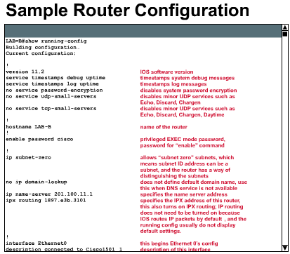
Just as computers need operating systems to run software applications, routers need the Internetworking Operating Software (IOS) to run configuration files. These configuration files control the flow of traffic to the routers. Specifically, by using routing protocols to direct routed protocols and routing tables, they make decisions regarding best path for packets. To control these protocols and these decisions, the router must be configured.
You will spend most of this semester learning how to build configuration files from IOS commands in order to get the router to perform the network functions that you desire. While at first glance the router configuration file may look complex, by the end of the semester you will be able to read and completely understand them, as well as write your own configurations.
The router is a computer that selects the best paths and manages the switching of packets between two different networks. Internal configuration components of a router are as follows:
- RAM/DRAM -- Stores routing tables, ARP cache, fast-switching cache, packet buffering (shared RAM), and packet hold queues. RAM also provides temporary and/or running memory for the router’s configuration file while the router is powered on. RAM content is lost when you power down or restart.
- NVRAM -- nonvolatile RAM; stores a router’s backup/startup configuration file; content remains when you power down or restart.
- Flash -- erasable, reprogrammable ROM; holds the operating system image and microcode; allows you to update software without removing and replacing chips on the processor; content remains when you power down or restart; multiple versions of IOS software can be stored in Flash memory
- ROM -- contains power-on diagnostics, a bootstrap program, and operating system software; software upgrades in ROM require replacing pluggable chips on the CPU
- interface -- network connection through which packets enter and exit a router; it can be on the motherboard or on a separate interface module
Students have been introduced to WANs; and reminded of routers. Now it's time to put the two together - what do routers in a WAN look like? What do they do? Lead the students, via Mini-Lecture, through graphics 2 through 5. Especially graphic 3, which shows many routers connected via many WAN links. Other Best Practices for teaching this TI include Online Study with Study Guides and a Lab Activity (using the Engineering Journal). The Lab Activity takes approximately 20 minutes, and introduces the router as a hardware device
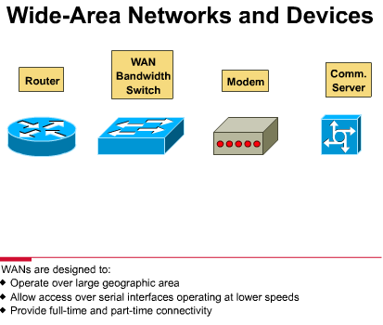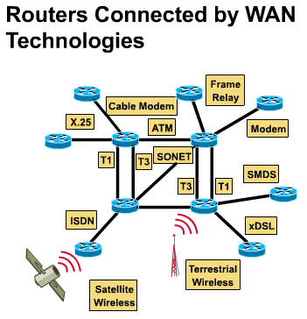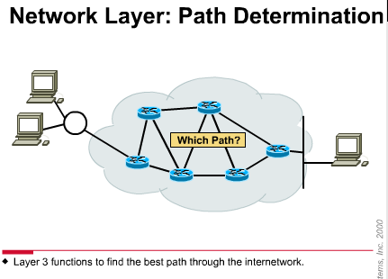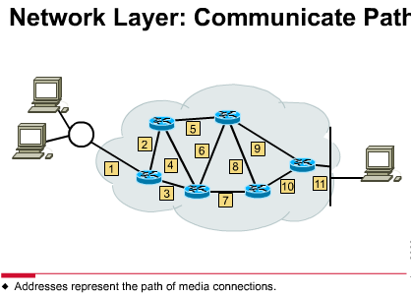
While routers can be used to segment LAN devices, their major use is as WAN devices. Routers have both LAN and WAN interfaces. In fact, WAN technologies are frequently used to connect routers. They communicate with each other by WAN connections, and make up autonomous systems and the backbone of the Internet. Since routers are the backbone devices of large intranets and of the Internet, they operate at Layer 3 of the OSI model, making decisions based on network addresses (on the Internet, by using the Internet Protocol, or IP). The two main functions of routers are the selection of best paths for incoming data packets, and the switching of packets to the proper outgoing interface. Routers accomplish this by building routing tables and exchanging the network information contained within them with other routers.
You can configure routing tables, but generally they are maintained dynamically by using a routing protocol that exchanges network topology (path) information with other routers.
If, for example, you want any computer (x) to be able to communicate with any other computer (y) anywhere on earth, and with any other computer (z) anywhere in the moon-earth system, you must include a routing feature for information flow, and redundant paths for reliability. Many network design decisions and technologies can be traced to this desire for computers x, y, and z to be able to communicate, or internetwork. However, any internetwork must also include the following:
- consistent end-to-end addressing
- addresses that represent network topologies
- best path selection
- dynamic routing
- switching
In this lab you will examine a Cisco router to gather information about its physical characteristics and begin to relate Cisco router products to their function. You will determine the model number and features of a specific Cisco router including which interfaces are present and to which cabling and devices they are connected
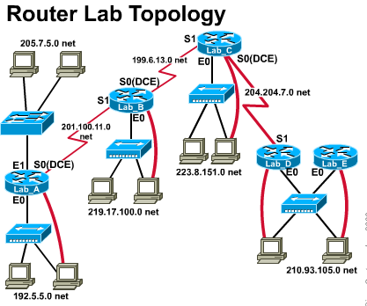
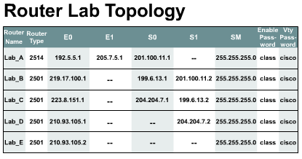
In graphic 1, the lab topology used throughout semester 2 is introduced. You cannot overemphasize that this lab topology, while seemingly simple and small (it exists on your 1 equipment rack or within your lab room), is a model WAN. Some people even label the routers - Toronto, Paris, Rome, Tokyo, Manila (etc.) - to emphasize that these routers might as well be separated by one of the WAN links described in TI 2.2.2, graphic 3. TI 2.2.3, graphic 3, gives another way to look at the Internet - as a collection of autonomous systems (using the vocabulary of the routing protocol OSPF) all interconnected by border and backbone routers running BGP routing protocol. This diagram is for descriptive, not quantitative or configuration, purposes. The first Lab Activity (using an Engineering Journal), takes about 20 minutes, is building the physical topology of the semester 2 labs. Small student groups should start from scratch and build the complete topology, and then take it all apart and let the next group do the lab. Thus note that only 1 lab group can be performing this lab at a time. This is a good place to start the students thinking about troubleshooting the Layer 1 issues that occur in Semester 2. It's also a fairly simple and very fun activity. The second Lab Activity (with an Engineering Journal), also takes about 20 minutes, is of incredible pedagogical importance. You, as the Lab Instructor (or an assistant of yours), should completely configure all of the routers and make sure you have complete connectivity. The students will then study this perfect configuration. They will not know how to create this configuration; hold this as an example of the skills they will need to have by the end of Chapter 8. Again, the purpose of this is to contextualize the long and difficult process of mastering dozens of IOS commands. If they master the commands, they can create useful configurations that can act as fundamental parts of WANs and the Internet.
The Semester 2 lab topology should be thought of as an enterprise WAN for a medium-sized company with offices around the world. It is not connected to the Internet; it is the company's private network. Also, the topology, as shown, is not redundant -- a failure of any router along the chain will break the network. This network of networks, under a common administration (the company) is called an autonomous system. -
The Internet is a network of autonomous systems, each of which has routers that typically play one of four roles.
- internal routers -- internal to one area
- area border routers -- connect two or more areas
- backbone routers -- primary paths for traffic that is most often sourced from, and destined for, other networks
- autonomous system (AS) boundary routers -- communicate with routers in other autonomous systems
While no one entity controls them, the typical entities are:
- corporations (e.g. MCI Worldcom, Sprint, AT&T, Qwest, UUNet, France Telecom)
- universities (e.g. University of Illinois, Stanford University)
- research institutes (e.g. CERN in Switzerland)
- Internet Service Providers (ISPs)
Although the Semester 2 topology is not a model of the Internet, it is a model of one topology that might represent an autonomous system. The protocol that is routed almost universally is IP; the routing protocol Border Gateway Protocol (BGP) is widely used among the Internet routers.
Router A is in Kuala Lumpur, Router B in San Francisco, Router C in New York City, and Router D and E in Paris. Each of the routers connects to an office or campus LAN. The connections from A-B, B-C, and C-D are leased T1 lines that are attached to the routers' serial interfaces.
Note that each router has an Ethernet LAN attached to it. Typical devices on Ethernet LANs, hosts are shown along with their console cables to allow configuration and display of the routers' contents. Also note that four of the routers have wide-area serial connections between them.

